VISUALIZATION TOOL FOR ELECTRIC VEHICLE CHARGE AND RANGE ANALYSIS.

1.INTRODUCTION :

A vehicle that can be powered by an electric motor that draws electricity from a battery and is capable of being charged from an external source and have an electric motor instead of an internal combustion engine.

The Electric Vehicle (EV) is not new, but it has been receiving significantly more attention in recent years. Advances in both EV analytics and battery technologies have led to increased automotive market share. However, this growth is not attributed to hardware alone. The modern mechatronic vehicle marries electrical storage and propulsion systems with electronic sensors, controls, and actuators, integrated closely with software, secure data transfer, and data analysis, to form a comprehensive transportation solution. Advances in all these areas have contributed to the overall rise of EV’s, but the common thread that runs through all these elements is data analytics.

The new EV’s are combined Electrical storage and propulsion systems with electronic sensors, controls, and actuators, integrated closely with software, secure data transfer to form a comprehensive transportation solution.

2.PROBLEM DEFINITION AND DESIGN THINKING :

EMPATHY MAP :



BRAINSTROM :

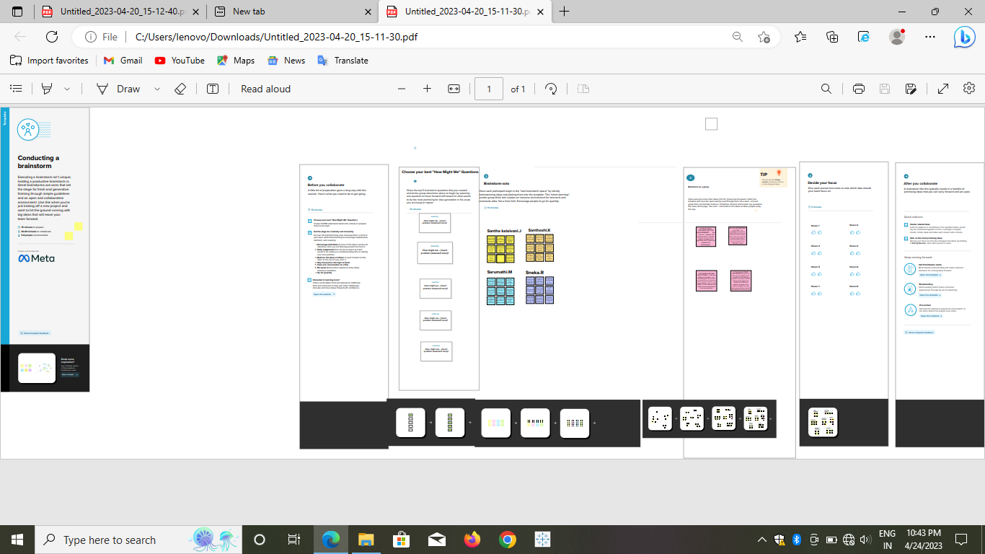

3.RESULT :



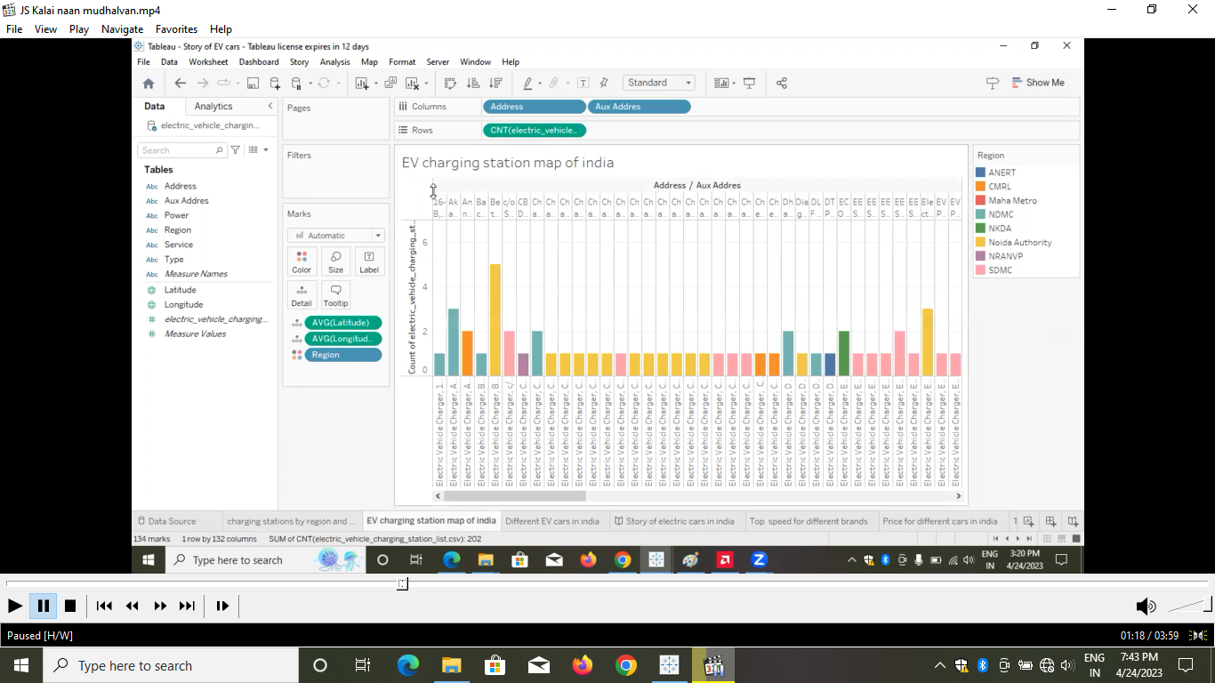















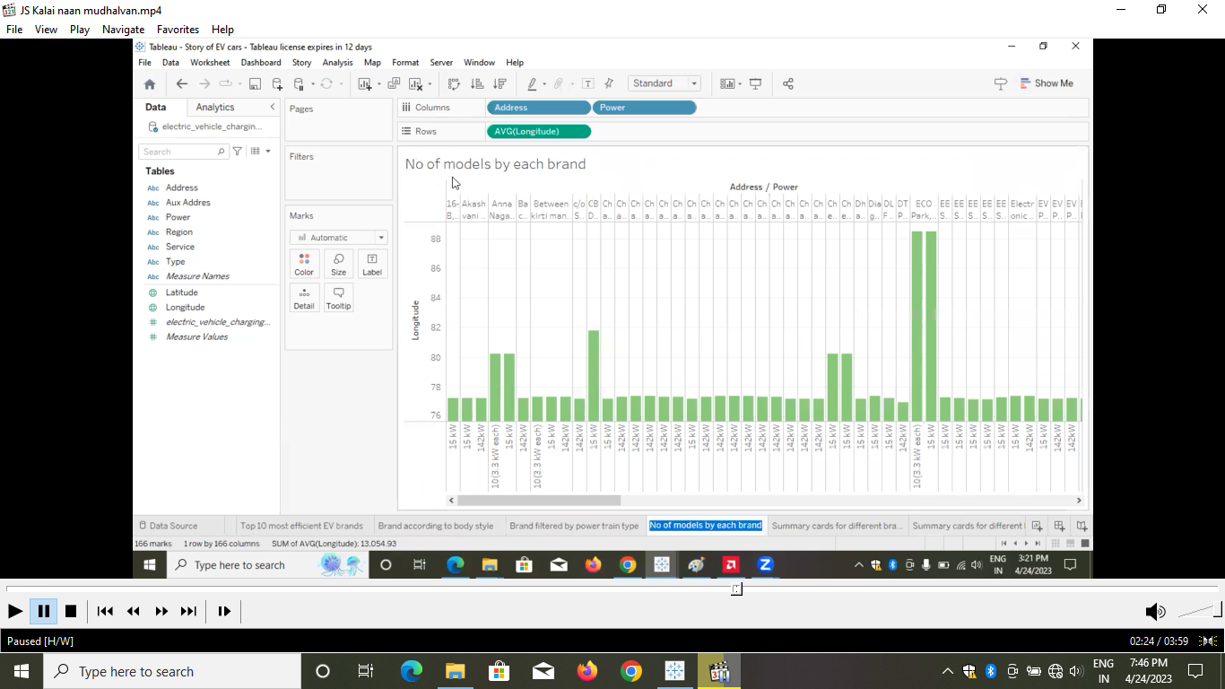



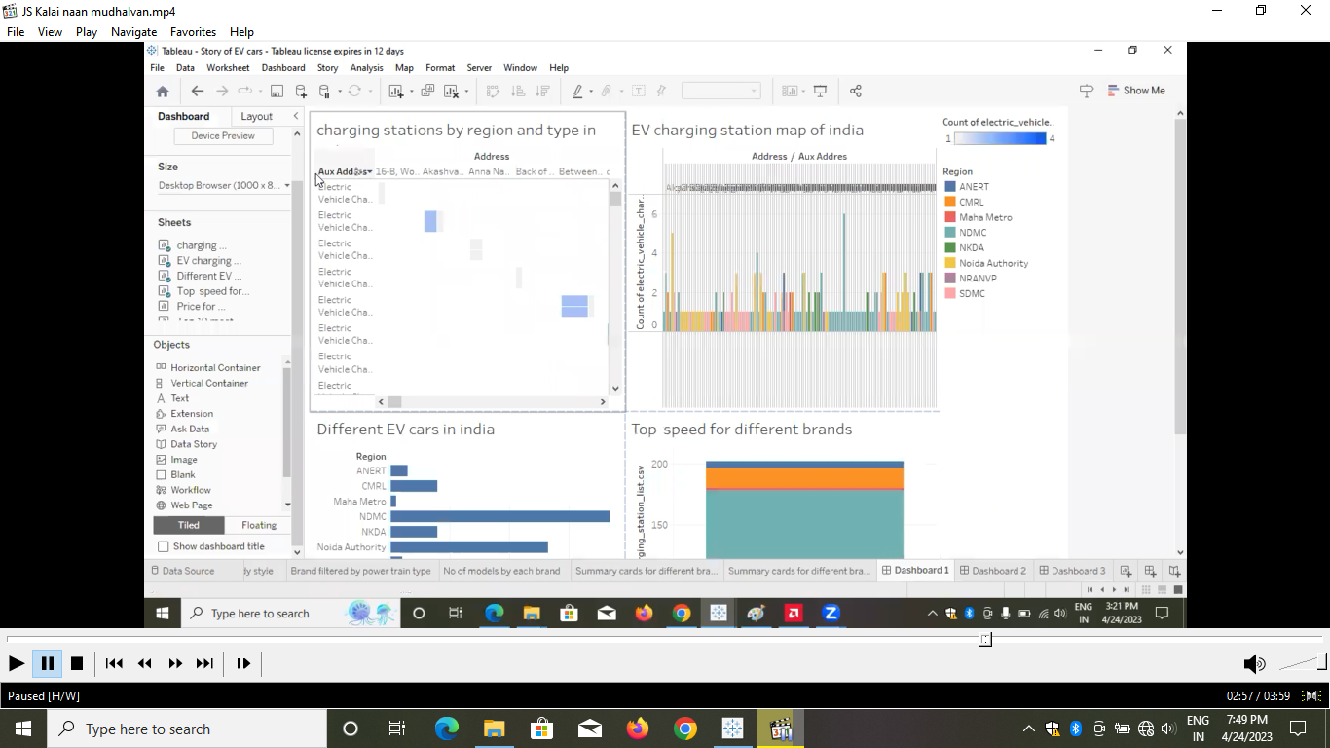

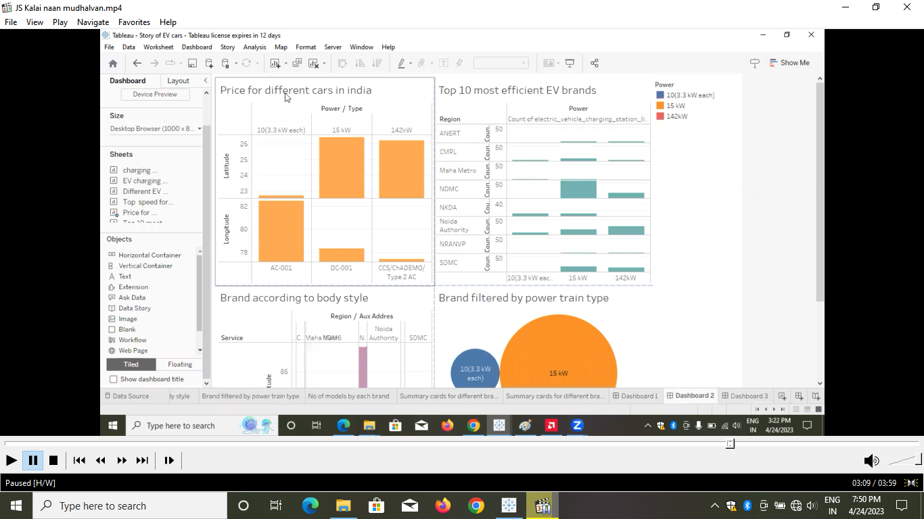





4.ADVANTAGES :

No fuel, no emissions

One of the most significant advantages of EVs is their impact on our environment. Pure EVs have zero tailpipe emissions, which reduces air pollution. Since the electric motor of the EV operates on a closed circuit, it does not emit any harmful gases

Electric motors lose very little energy as they are extremely low friction and heat up less than combustion engines. Electric vehicle motors are extremely efficient – with calculated values ranging from around 80 to over 90 percent efficiency.

Benefits Of Using An Electric Scooter is not required to have a driver's licence. Use with minimal effort. Electric scooters are environmentally friendly. There is no noise pollution.

5.DISADVANTAGES :

i) Higher Purchase Cost. Compared to regular automobiles, electric vehicles are highly pricey.

ii) Low Speed and Range.

iii) Low Price on Selling.

iv) The Inconvenience of Service Station.

v) Low Energy.

vi) Battery Expenses.

vii) Slow Charging.

Viii) Expensive Recharging Options.

6.APPLICATIONS :

i) Active Suspension.

ii) Braking and Stability Control.

iii) Diesel Engine Management.

iv) Electrification.

v) Electric Power Steering (EPS)

vi) Motorcycle Engine Control Unit (ECU) and Small Engine Control.

vii) Transmission and Gearbox.

viii) Energy Storage Systems

7.CONCLUSION :

The progress that the electric vehicle industry has seen in recent years is not only extremely welcomed, but highly necTheessary in light of the increasing global greenhouse gas levels.

8.FUTURE SCOPE :

The Economic Survey 2023 predicts that India's domestic electric vehicle market will see a 49 percent compound annual growth rate (CAGR) between 2022 and 2030, with 10 million annual sales by 2030. Additionally, the electric vehicle industry is projected to create around 50 million direct and indirect jobs by 2030.

9.APPENDIX :

https://drive.google.com/file/d/1KhOky425-kq9gOf2oz0uRzbHZH1-rUDt/view?usp=drivesdk